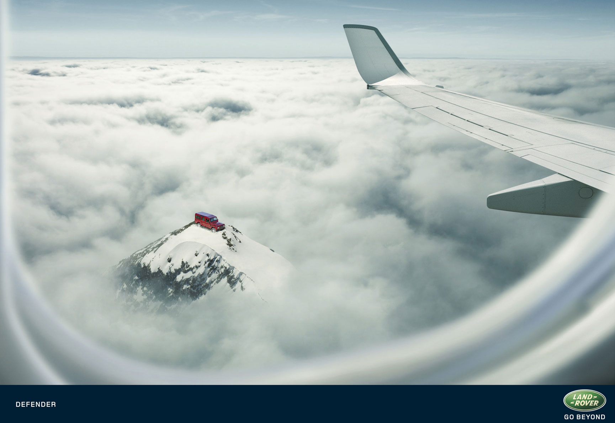
Look Mother, our Andrews come to wave us off

